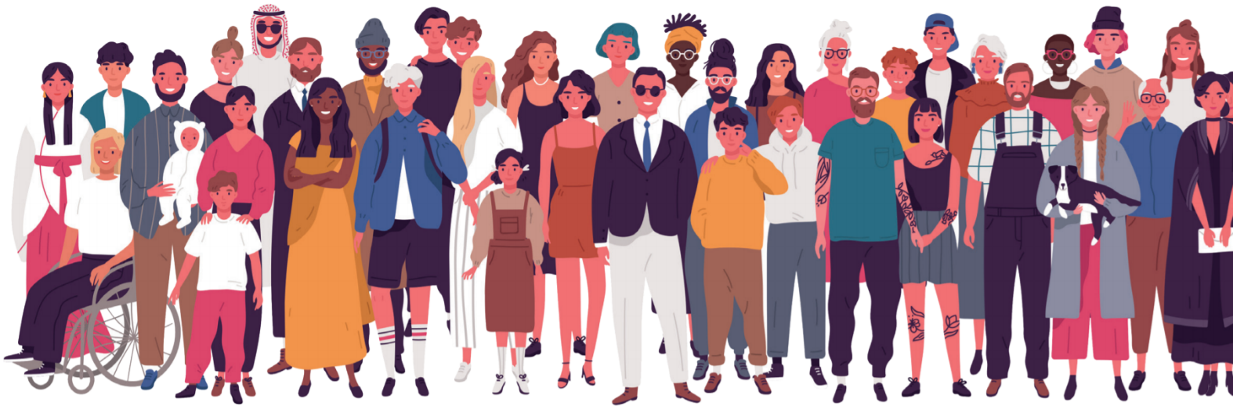
Reflective Practice Activity
Accessible to all

Please work your way through the article on pages 14 – 19 of the 2020 Autumn issue of International Therapist Magazine. Once completed you can award yourself 5 points towards your continuing professional development.

Name: | Membership number:

Our survey says… (p.14 – 15)
Take a look at the survey results within this article. Describe below how you relate to the result. Do you agree with the statements included or do you find your experience to be different?

Write your answer here:

Read, reflect and respond
Work your way through the article and complete the sections below as you. Make sure to keep your therapy practice in mind when completing the activities.
Tip: Use the tool to highlight any actions for you to take after completing this reflection.

LGBTQ+ (p.15 - 16)
What were some of the examples of anxieties which someone from the LGBTQ+ community may feel when going to a clinic?
Write your answer here:

LGBTQ+ (p.15 - 16)
Working your way through the four ways to ensure your practice is LGBTQ+ inclusive and list actions which you can take to ensure that your practice can be inclusive.
Disclosing gender

Approaching treatment collaboratively

In and around your practice

Professional development

Localisation (p.16)

Do some research in your local area to see the demographic of those who live in your area. Work through the below and see if your client base is a good representation of the community which you live in.
Tip: you can use https://www.streetcheck.co.uk/ to get a good idea of your area.
 | Your area | Your client base
Gender

Age groups

Ethnic groups

Religion

(Add your own here)

Financial (p.16)
Looking at Denise Berwick’s tips on how she supports her clients financially, do you feel that you could implement any of these ideas in to your practice? If so, how?
Write your answer here:

BAME community (p.17)
After reading Hinna’s piece on steps which she takes to make her therapy practice more inclusive to the BAME community, can you think of ways that you can do this in your practice?
Write your answer here:

Six ways to make your therapy practice more inclusive (p.32)
Take a look at page 32’s ‘six ways to’ and work your way through each point, thinking about your own practice.
- Imagery

- Additional knowledge

- Reach out

- Tailor your products

- Language

Further reading (p.19)
It is so important to keep educating yourself on this topic, take a look at the useful resources list and start by picking one resource which you feel would help you on your next step in your development.
Write below why you have picked this resource and what you hope to gain from it:

Your next step: Unconscious bias
The idea of unconscious bias, which are your unconscious attitudes towards certain groups of people, is a great area to explore. You can try a test on the Project Implicit website to take a look at your own unconscious bias.

Further training
To be informed of upcoming training on Diversity and Inclusion, please email education@fht.org.uk

